Filter Arduino Analog Signal

Arduino Digital Low-Pass Filter 2.0
Arduino Analog Signal Filter, Analog sensor value Fluctuates a lot
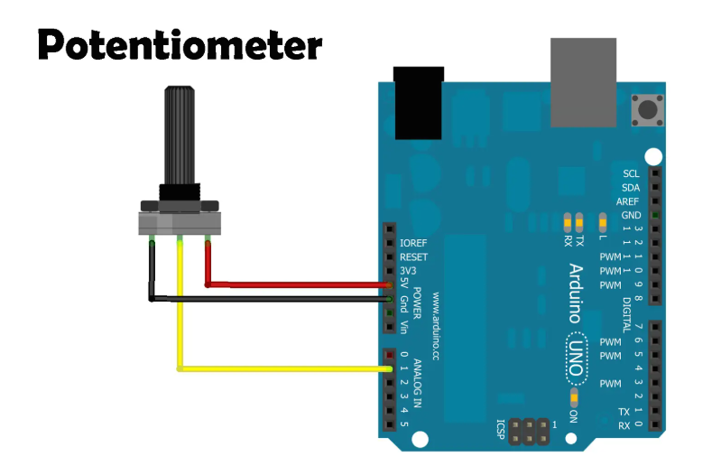

Arduino_Pot_Basic.ino
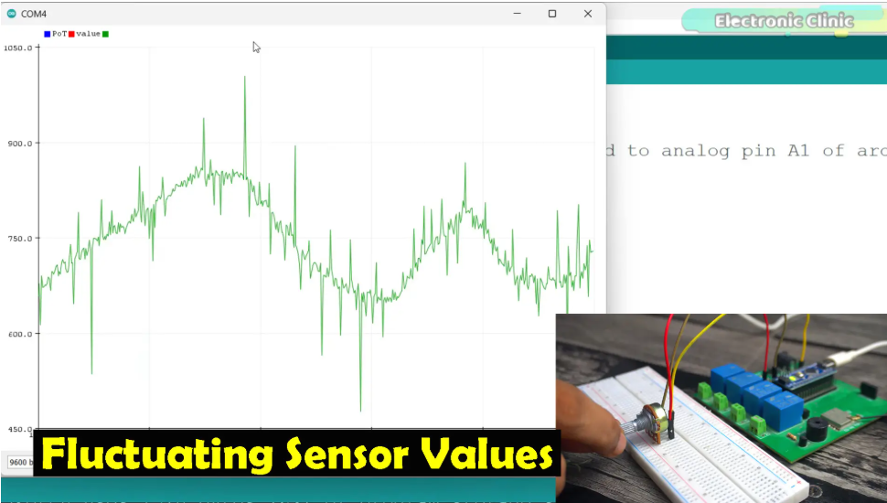
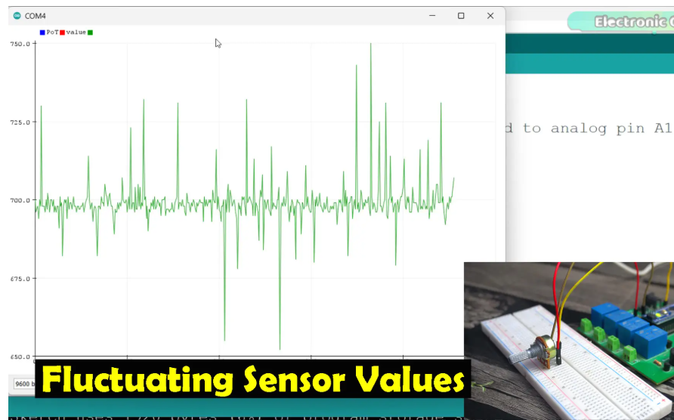

Arduino_Analog_Value_Averaging.ino
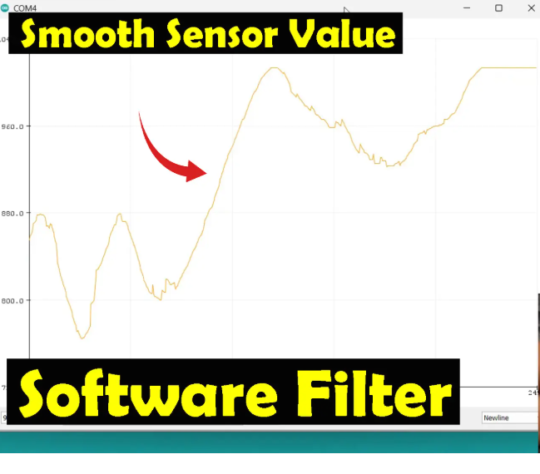
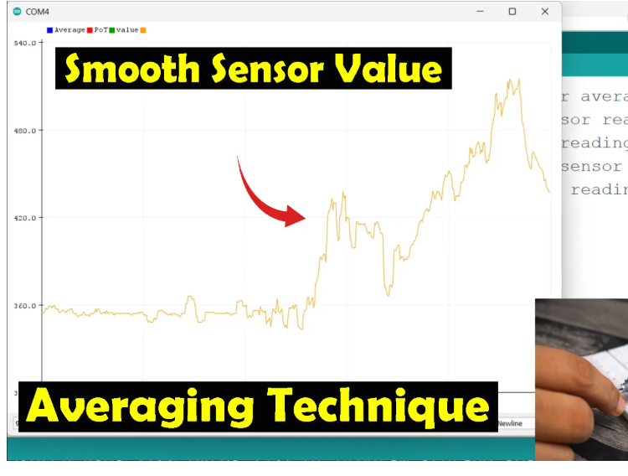

Arduino_Filter.ino
In this equation:
“alpha * PotData” This part of the equation takes the new sensor reading and multiplies it by alpha. If alpha is 0.1, it means that 10% of the new reading is used in the final filtered value. You can try different values from 0.1 to 0.9.
“(1 – alpha) * filteredValue” This part takes the previous filtered value and multiplies it by (1 – alpha). If alpha is 0.1, then (1 – alpha) is 0.9. This means that 90% of the previous filtered value is kept in the new filtered value.
By combining these two parts, the filter smooths out the fluctuations in the sensor readings. The result is a filteredValue that changes more slowly and is less noisy compared to the raw PotData.

